CentOS
Install Tmux on Centos
We use sudo dnf install tmux -y
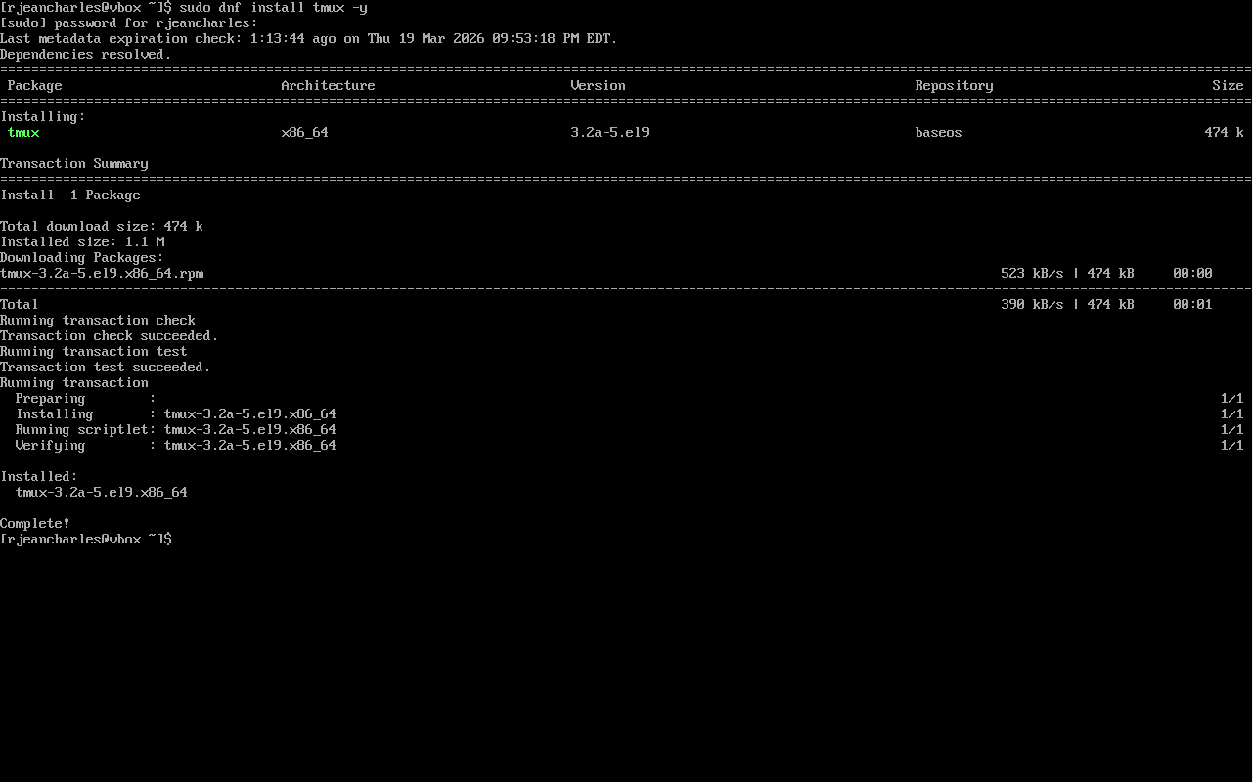

Install emacs on CentOS
We use sudo dnf install emacs -y
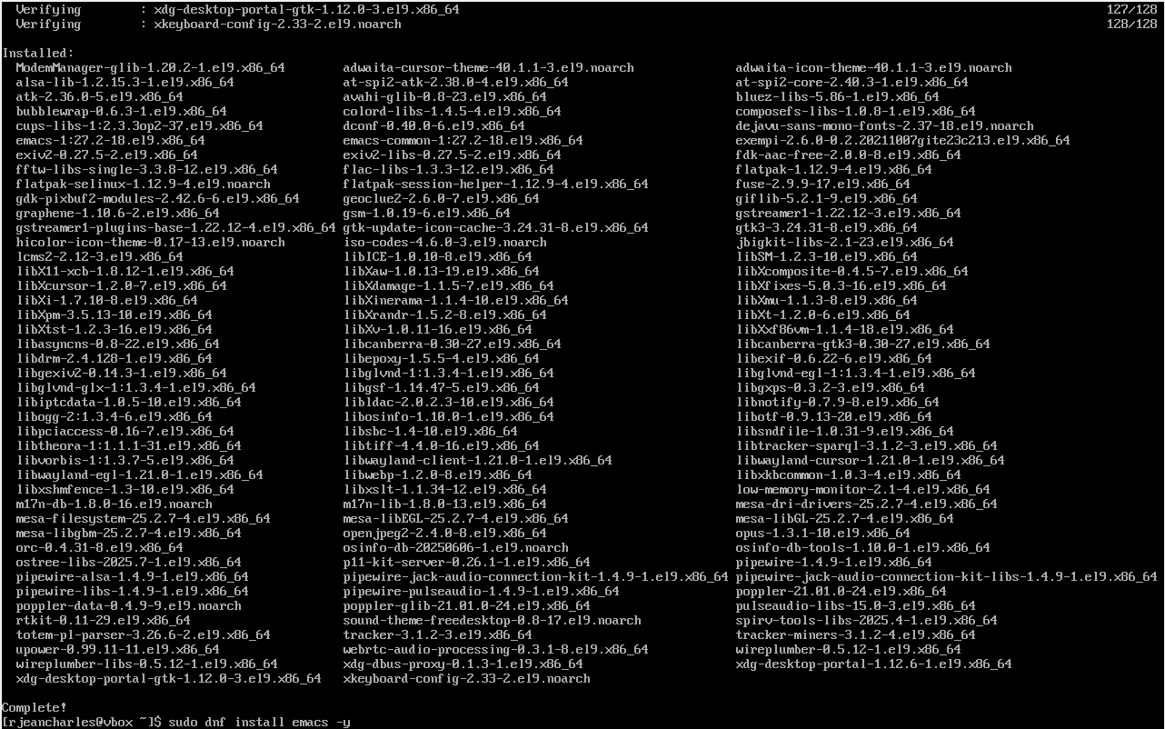

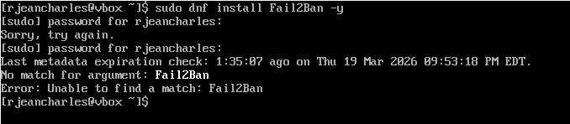

Fail2Ban cannot be installed using default repositories because it is not available in BaseOS or AppStream.”

We have to install epel repository
Command use : sudo dnf epel-release -y
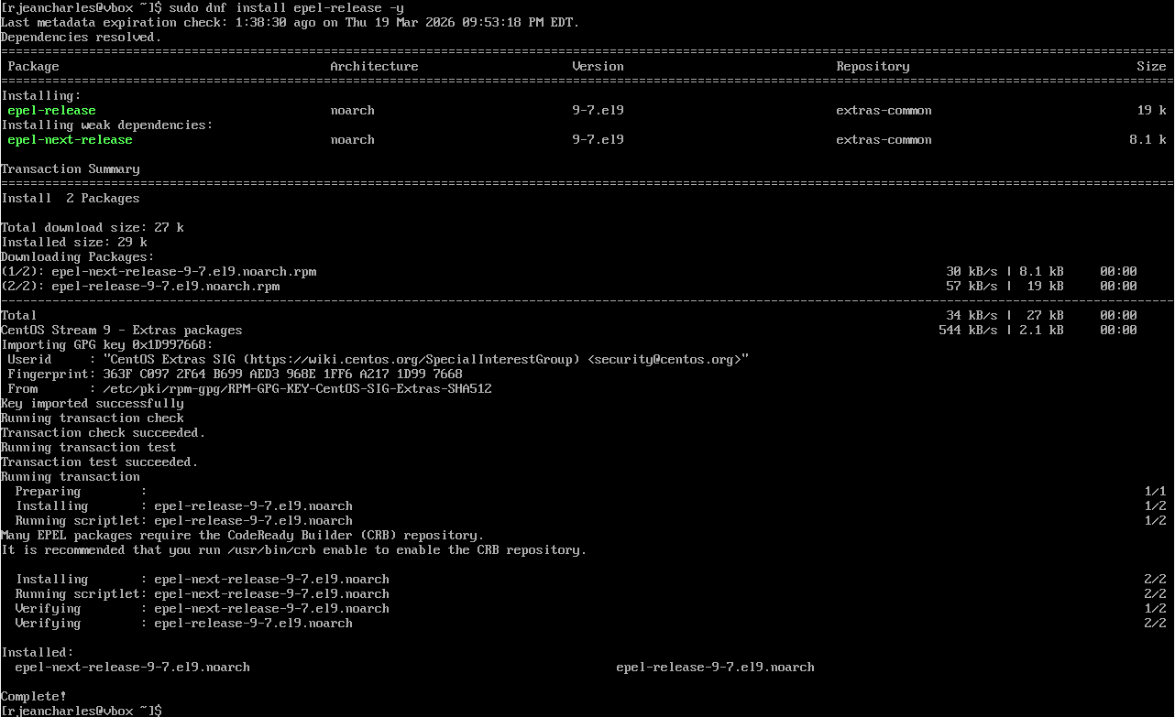

Verify Epel repository are available.
Command use : dnf repolist
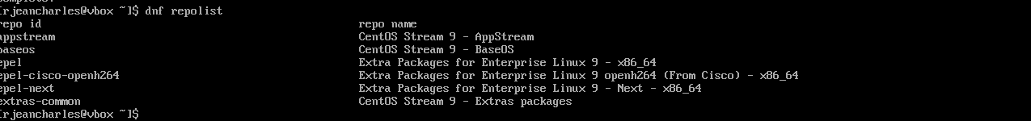
.

Fail2ban is now installed, we need to configurate it.
Command use : sudo dnf fail2ban -y
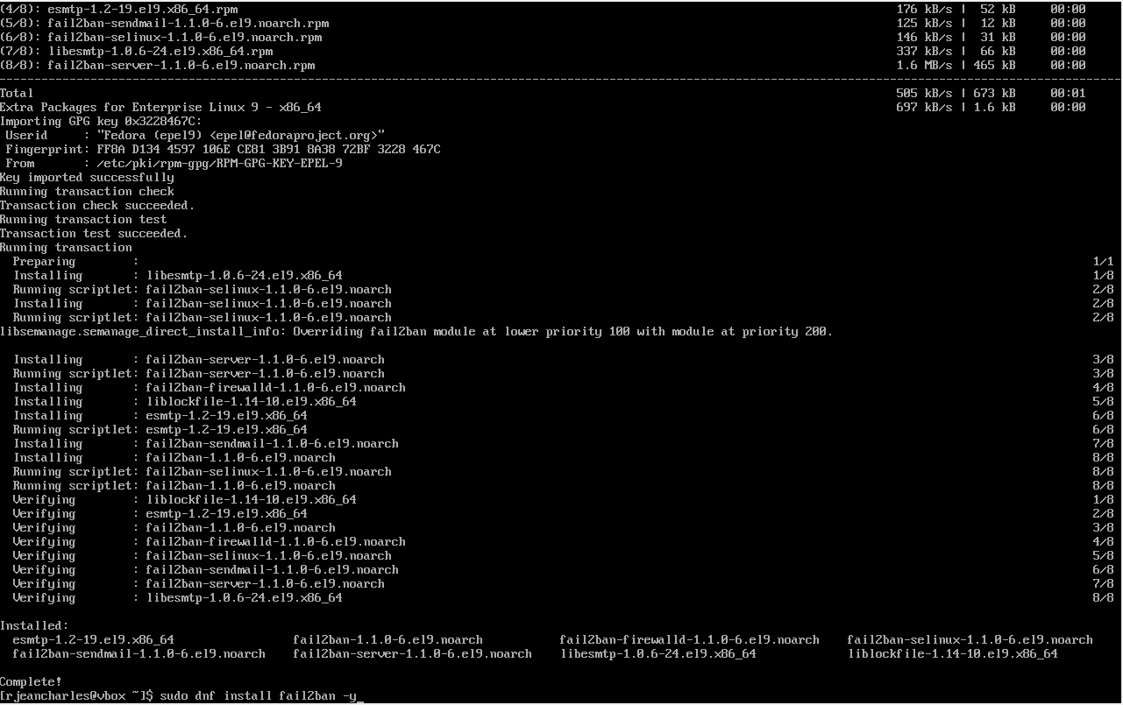
Fail2ban is now installed, we need to configurate it.

As you can see it is inactive, so we need to make it active by configurate it.
Command used to check the status is : sudo systemctl status fail2ban
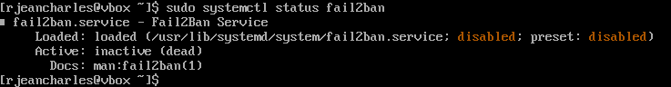
As you can see it is inactive so we need to make it active by configurate it.

To configurate use command sudo nano /etc/fail2ban/jail.local
Type this information to configurate
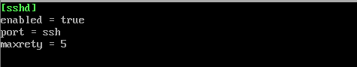

Restart fail2ban in order to activate and verify if it’s working
Command use : sudo systemctl restart fail2ban
sudo fail2ban-client status
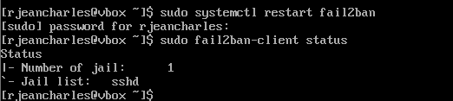
Restart fail2ban in order to activate.

Install cowsay
Command use : sudo dnf install cowsay -y

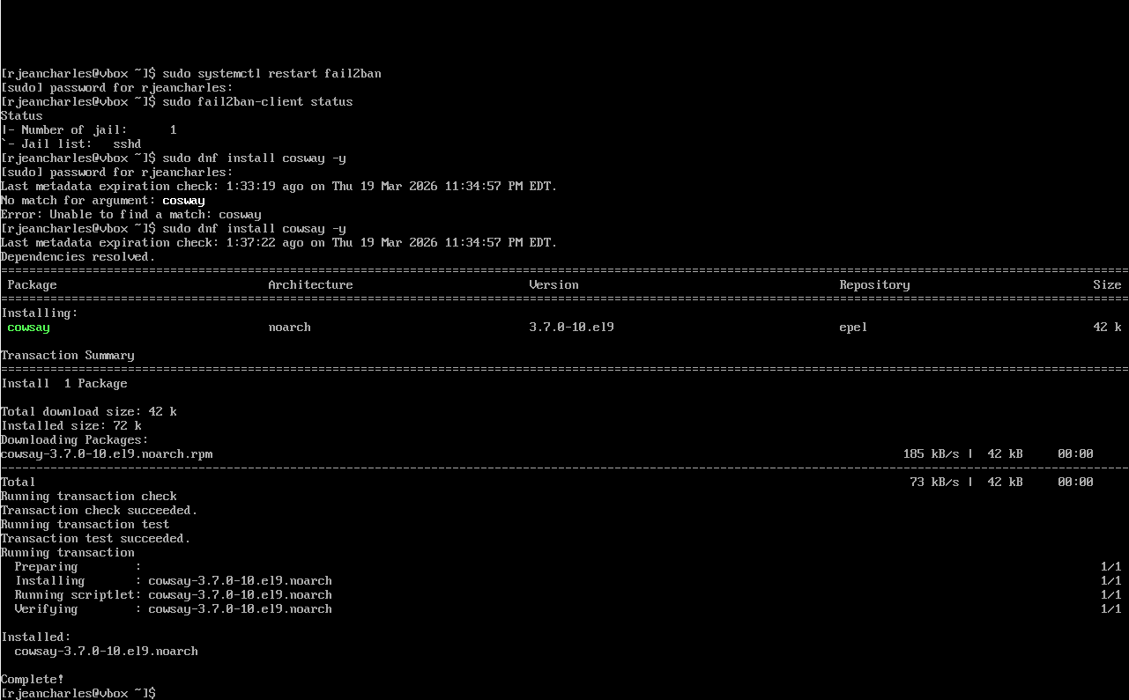

Verify it’s working
Command use : cowsay Hello

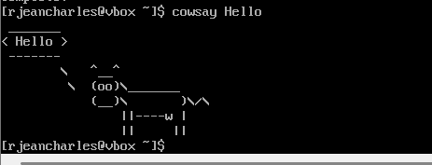

Install lolcat
Command use : sudo dnf install lolcat -y
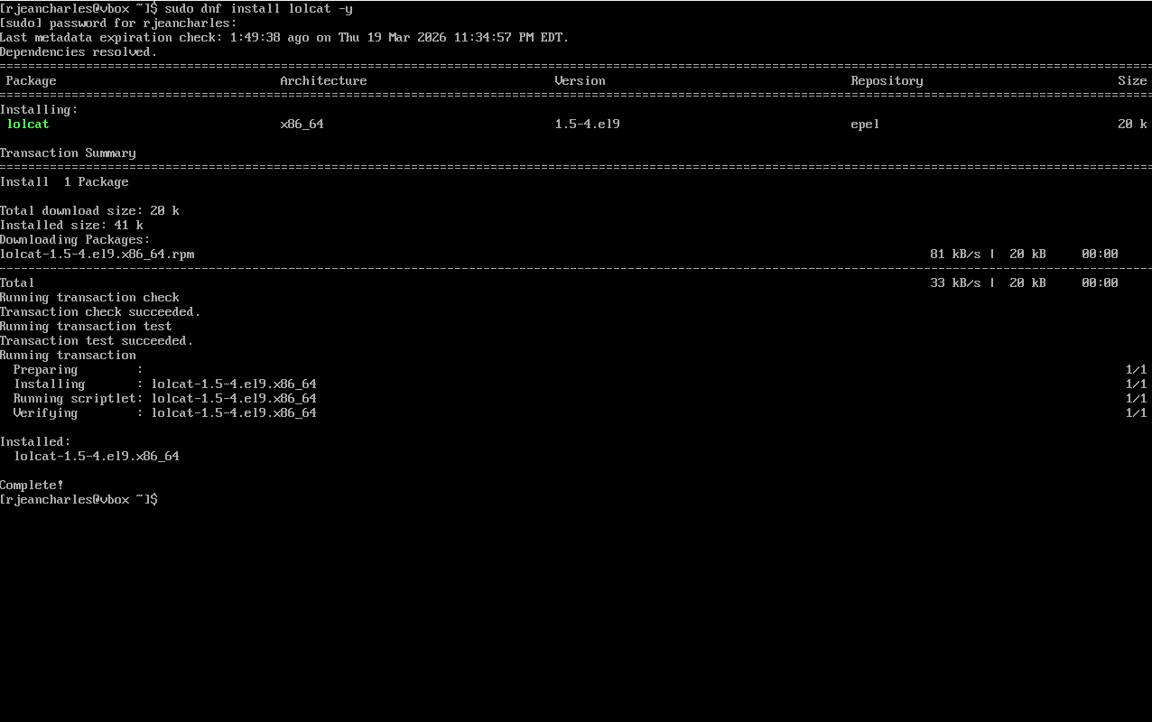

Verify it’s working
Command use : ls -l | lolcat
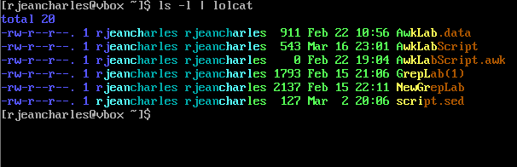

Install vim
Command use sudo dnf install vim -y
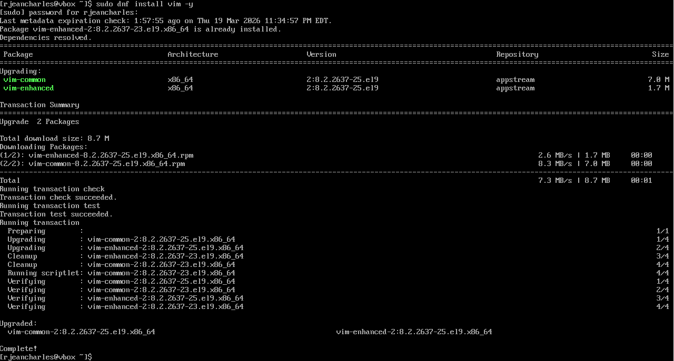
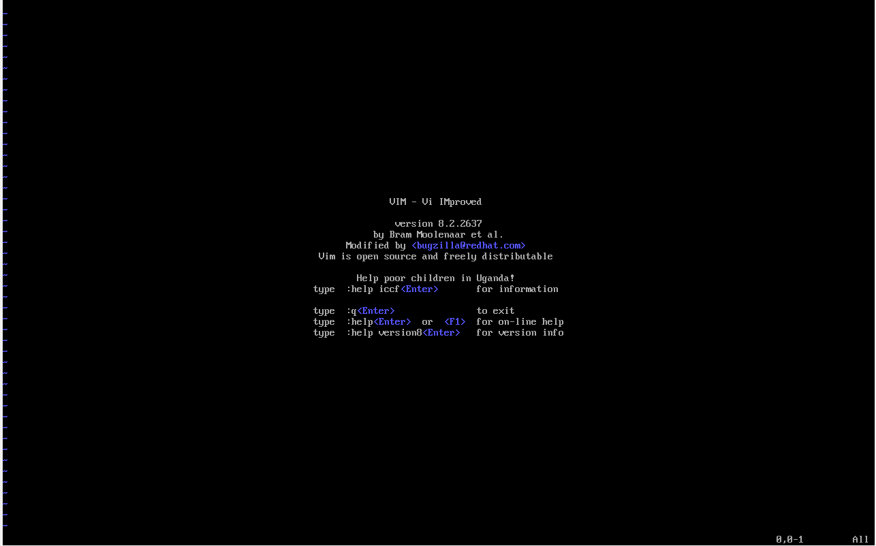

Create files and save them
Command use : vim
Press i to insert text
Esc to exit
Save file with wq:

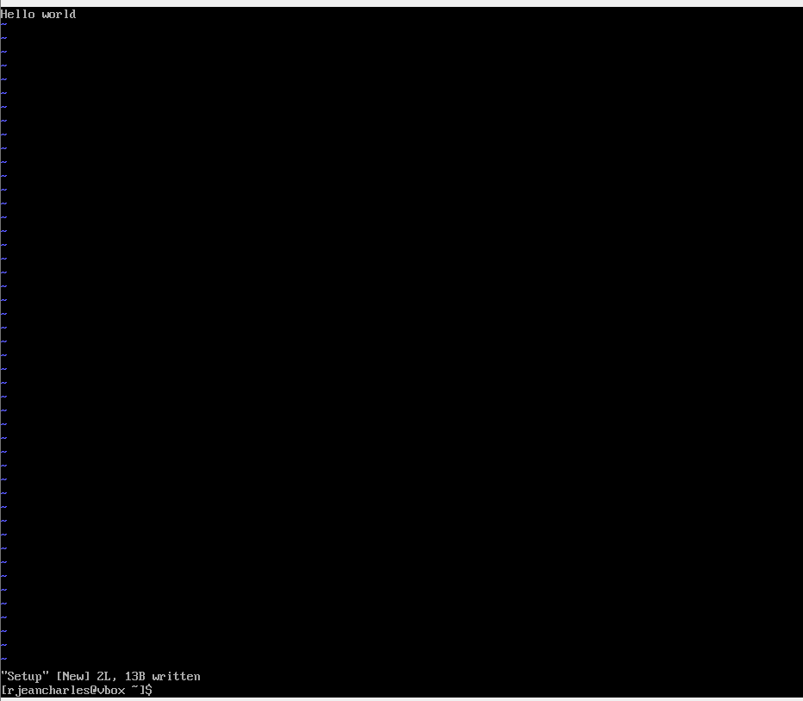

Ubuntu

When I tried to install Tmux it was already installed on ubuntu since I have the latest version.
Command use : sudo ap install tmux
-y

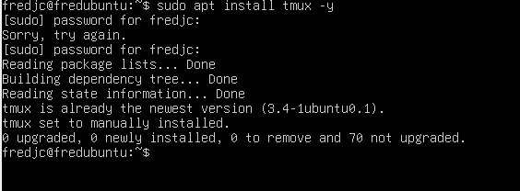

Install emacs
Command use : sudo ap install emacs -y
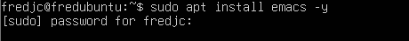

After entering password this screen prompt,
While installing, Postfix configuration appears. It is important to select local only because the system will not be use as a mail server

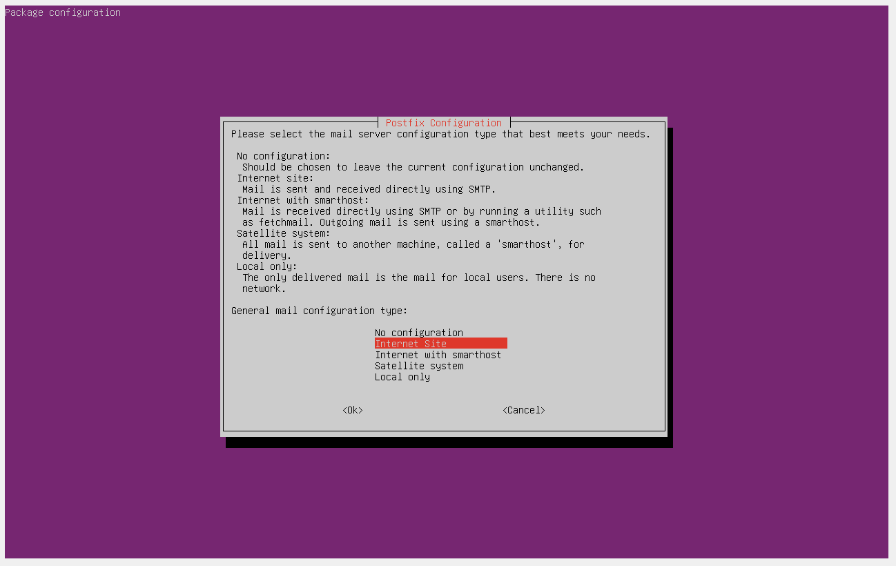

Confirm the configuration with the name user and click ok
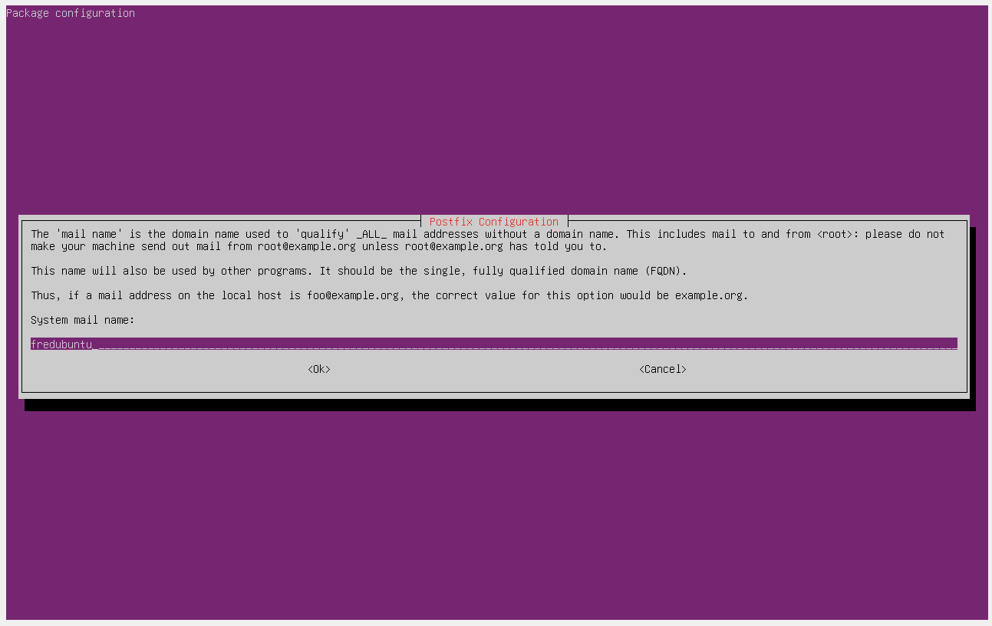

Here press Tab and click enter
The Installation is complete for emacs after configuring postfix, selected Local Only to not set up a mail server.

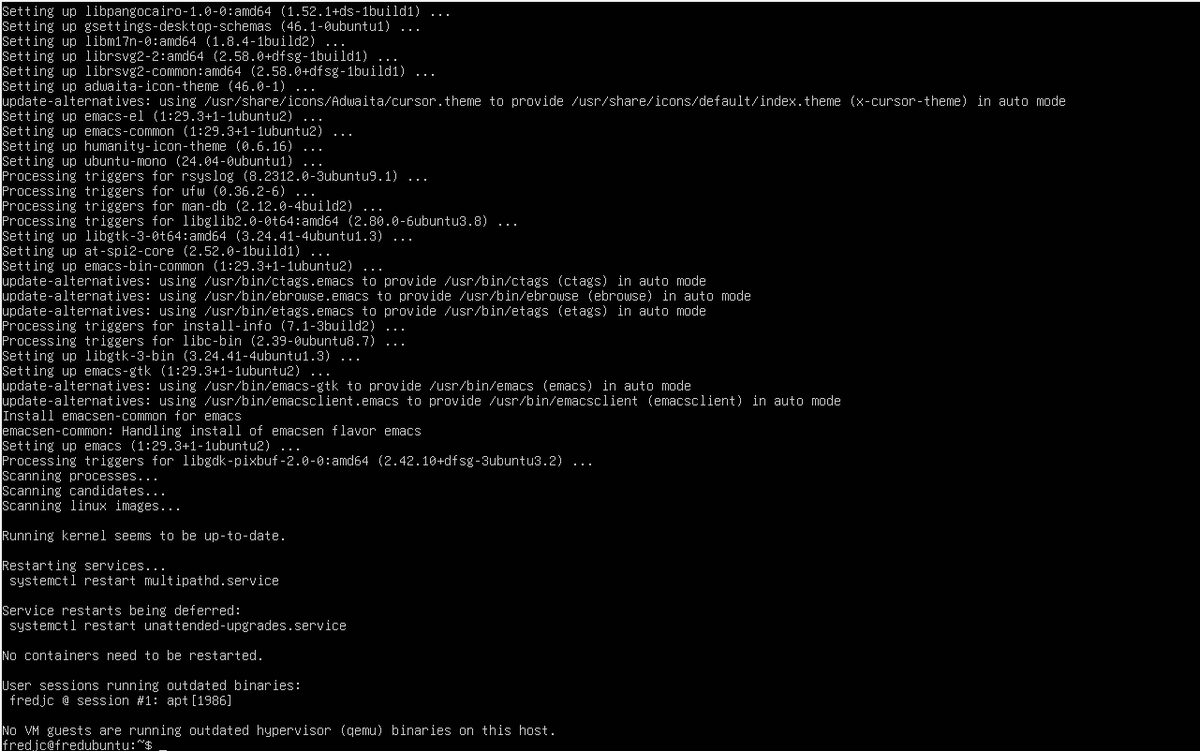

Install fail2ban
sudo ap install fail2ban -y

After entering password
Fail2ban is completely installed without needing an additional repository unlike CentOS where EPEL were required.

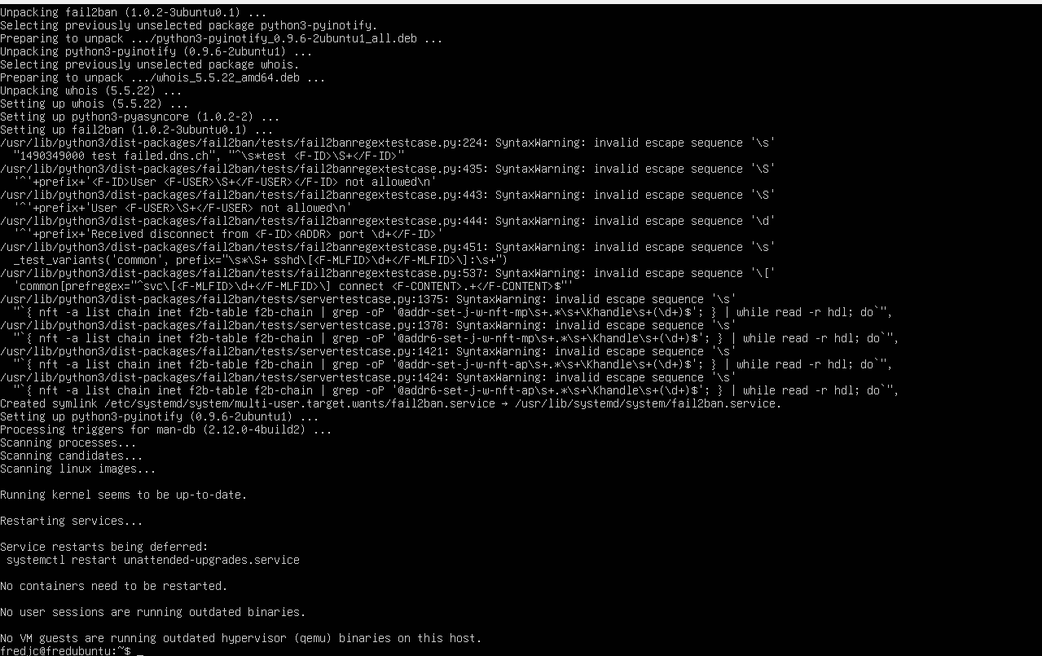

Configuration on fail2ban
Command use : sudo nano /etc/fail2ban/jail.local
Type the script
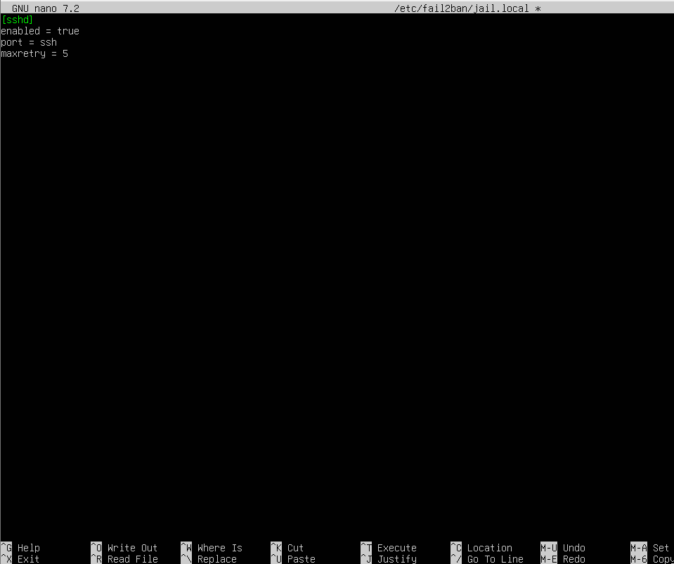

Save file
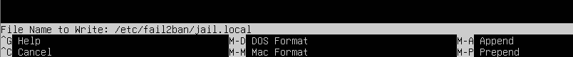

Start running fail2ban while enable it
Command use : sudo systemctl enable fail2ban

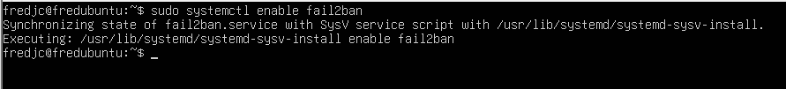
Completing the process
Command use : sudo systemctl start fail2ban

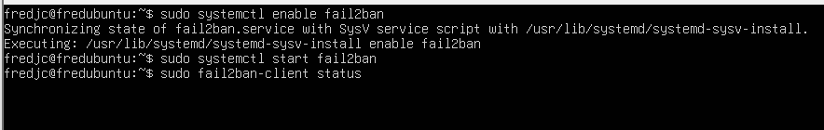

sudo fail2ban-client status
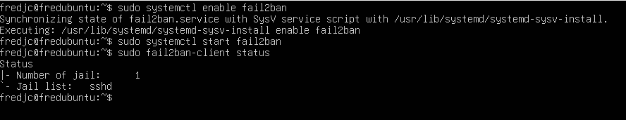
Fail2ban is working right now on the server.

Install Cowsay
Command use : sudo apt install cowsay -y
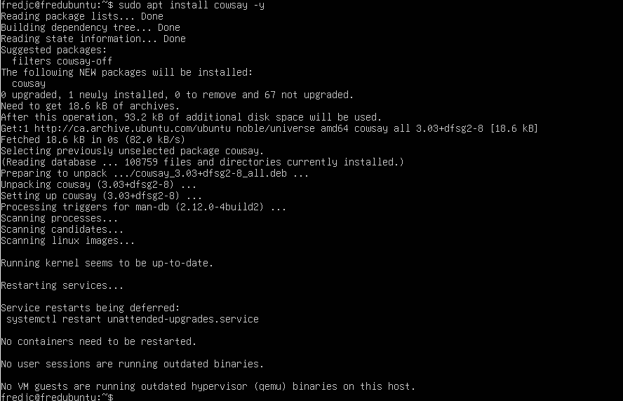

Verify Cowsay is installed
Command use : cowsay Hello
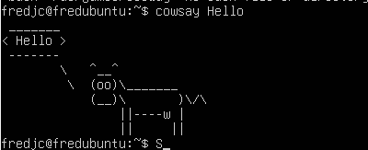
It’s working

Install lolcat
Command use : sudo apt install lolcat-y

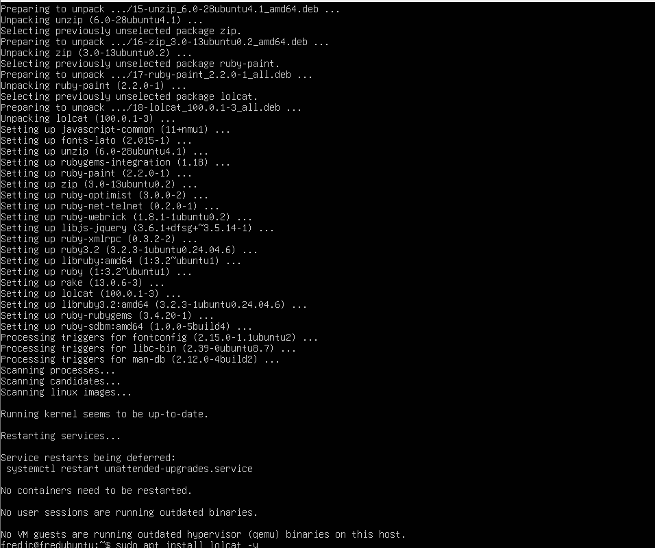

Verify lolcat is installed
Command use : ls -l | lolcat
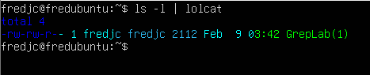

Test vim command

Vim is already installed

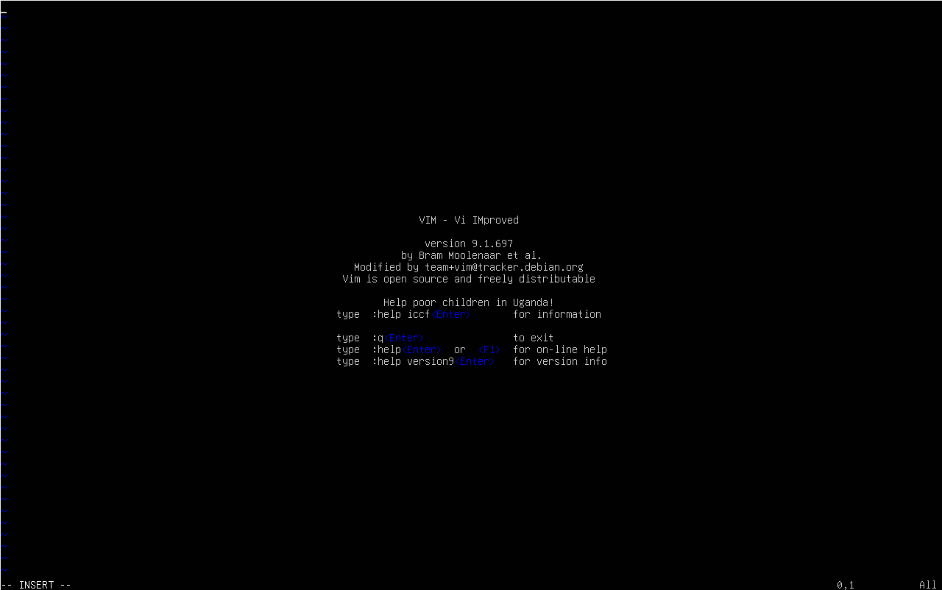

Type i to type text
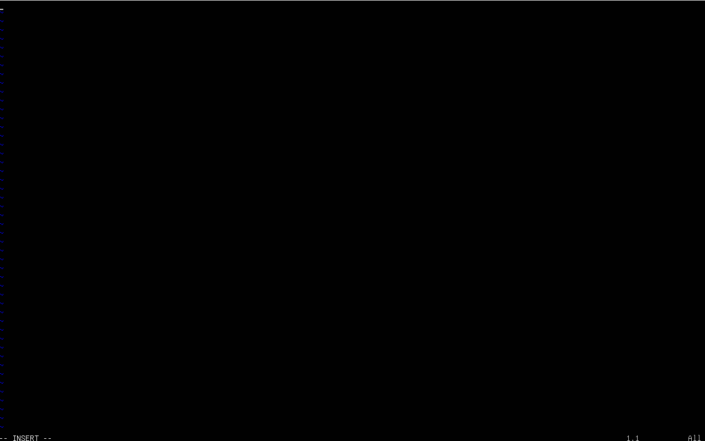

Create a file named new file with vim
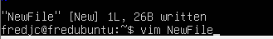

Verify if the file is saved
Command use : cat Newlife
